2019 Annual General Meeting Agenda
Coldstream Women’s Institute, Vernon BC
August 9th, 2019
CALL IN NUMBER: 1-855-392-2520
CONFERENCE ID: 9819389
12:30 p.m. Registration
1:00 p.m. Welcome & Chair (Garth Healey)
Minutes of the 2018 AGM (Serena Black)
Financial Report (Serena Black)
Election of Directors and Officers
CFGA Report – Update (Garth Healey)

1:45 p.m. New Business:
  - Manager Report – 2018/2019 Activities
    - Meetings/Conferences
    - Website Updates
  - Project Sub-Committee Update
    - Train the Trainers
    - FAIP Project
    - IAF Project
  - Weed Sub-Committee Update
  - Items from the Floor

3:00 p.m. Coffee Break

3:15 p.m. Guest Speakers

Laura Code, Regional Agrologist, Ministry of Agriculture
Dr. Lauchlan Fraser, Thompson Rivers University
Norm Dueck, A&L Labs

5:00 p.m. Adjourn AGM

ELECTION of DIRECTORS and OFFICERS

Officers 2018-2019 (one year term): Term:
President Garth Healey 2018 – 2019
Vice President Doug Hatfield 2018 – 2019
Treasurer Bill Awmack 2018 – 2019
Secretary Sheri Schweb 2018 – 2019

Directors up for election this year (two-year term):

Directors Affiliation Term

Bill Awmack Quality West Seeds 2017 – 2019
Corky Tucker Producer – Williams Lake 2017 – 2019
Garth Healey (CFGA Rep) Healey Hay & Strawdust Supply - Fraser Valley 2017 – 2019
David Clarke Producer – West Chilcotin 2017 – 2019
Shabtai Bittman Agriculture and Agri-Food Canada 2017 – 2019
Derek Hunt Agriculture and Agri-Food Canada 2017 – 2019
Sheri Schweb Producer – North Cariboo 2017 – 2019

Directors NOT up for election this year (two-year term):

Directors Affiliation Term

Mike Witt Producer - Okanagan 2018 – 2019
Jeremy Birky Agri-Business – Glendale Agra 2018 – 2019
Doug Hatfield Producer – Hixon 2018 – 2019
Rick Schmidt Producer – Kootenay 2018 – 2019
Erin Durrell Agri-Business – Union Forage 2018 – 2019
John Church Thompson Rivers University 2018 – 2019

Standing for Election for 2019-2020 Term:

Bill Awmack – Quality Seeds West
Corky Tucker – Central Cariboo
Garth Healey (CFGA Rep) – Fraser Valley, Healey Hay and Strawdust Supply
David Clarke – Chilcotin
Shabtai Bittman - Agriculture and Agri-Food Canada
Derek Hunt – Agriculture and Agri-Food Canada
Les Yates – Bulkley Valley

2019 AGM Guest Speakers

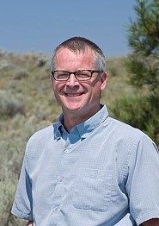
Climate Change and Ranch Management Practices in the BC Interior
Dr. Lauchlan Fraser, Professor
Thompson Rivers University

Dr. Lauch Fraser is a Professor and NSERC Industrial Research Chair in Ecosystem Reclamation at Thompson Rivers University. Dr. Fraser’s expertise is in grassland and wetland ecosystems, with a focus on ecosystem reclamation, biodiversity, range management, and climate change. External research funding has supported Dr. Fraser’s research, much of it in partnership with industry, including mining, oil and gas and agriculture. Lauch is the Associate Editor of two academic journals (Applied Vegetation Science and Plant Ecology) and founder and inaugural Director of the BC Interior Centre for Ecosystem Reclamation.

Soil Health –What’s in Your Bank Account?
Norm Dueck, Agronomy and Business Development Representative
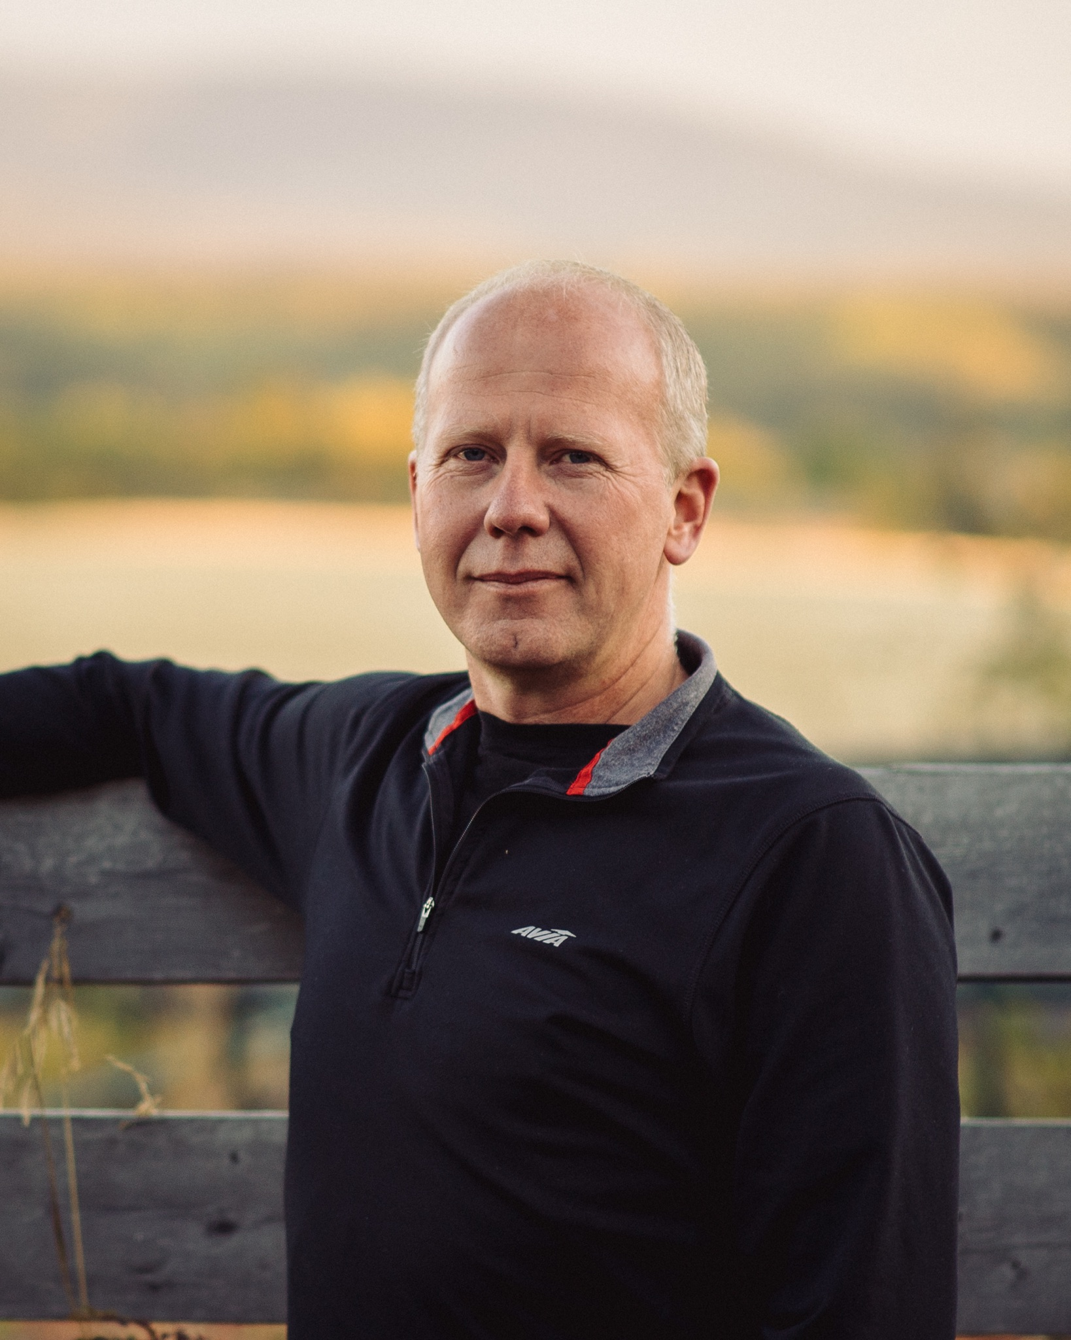
A&L Canada Laboratories

Norm has been involved in agriculture along the Hwy 16 corridor in the BC for the past 19 years as an agronomist. The last 4 of those years have been spent working as an independent crop consultant (Heartland Soil and Crop Solutions) for beef, dairy and grain farmers. Norm’s approach to agronomy is one of balance. If your soil nutrients are in proper balance to each other, your crop will show it and you will love it! His passion and love for agriculture has never been stronger!

Funding for this event is provided in part by the Canadian Agricultural Partnership, a five-year, $3 billion investment by the federal, provincial and territorial governments to strengthen the agriculture and agri-food sector.




